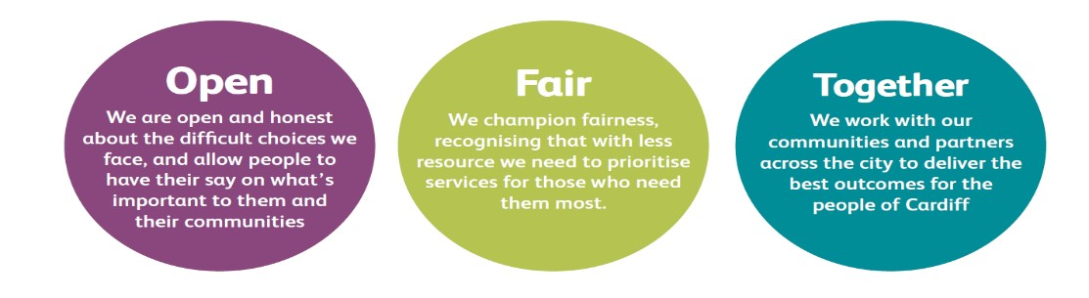

JOB DESCRIPTION AND PERSON SPECIFICATION
Job Title: Local Action Trainee | Directorate: Communities and Housing
Section: Estate Management Service | Reporting to: Local Action Supervisor
Grade: 3 | Hours per Week: 37
Post Number: TBC New post | Number of Employees Reporting to Post:
Special Conditions: Full and valid driving licence. Required to drive council vehicle.  Temporary post 18 months | Location of Post: Mobile throughout City.
Job Purpose:
To assist with providing a Clean and Clear service to Council estates and communal areas including housing land in and around City of Cardiff.

This will include the reporting of repairs, fly tipping and anti-social behaviour issues on a daily basis.

Also to engage with the community at localised events to provide support for removal of rubbish and overgrown areas.

Duties and Responsibilities
Job Specific Requirements

- To assist with the delivery of a high quality clean and clear service.

- To contribute to community engagement events to actively support the community.
- To undertake all duties in line with service area and corporate policies and procedures.

- To ensure risk assessments are followed and tasks are carried out and any council vehicle is driven in accordance with the council’s health and safety policy and the relevant procedures.

- Report repairs and ensure that if asbestos has been disturbed it is reported to Community Action Supervisor promptly.

- To assist with the clearance of properties, gardens and communal areas utilising appropriate plant and equipment as necessary.

- Liaise daily with Local Action Supervisor, reporting on issues arising.

- To contribute to the completion of work and targets.

- To contribute as a member of the Local Action Team.

- To practically assist in the operation and development of any Quality systems adopted by the service area.

- To support the application of current and emerging technology.

- To undergo necessary training and coaching and achieve NVQ certification.

- To practically participate in any quality systems adopted by the service area.

- To participate in supporting the principles and practice of equality of opportunity as laid down in the organization’s Equal Opportunities Policy.

- To take reasonable care for the health and safety of yourself and other persons who may be affected by your acts and omissions and to comply with all health and safety legislation as appropriate.

- As a term of your employment you may be required to undertake such other duties and/or times of work as may reasonably be required of you, commensurate with your grade or general level of responsibility within the organisation, at your initial place of work or based at any other establishment.

Corporate Requirements
- To participate actively in supporting the principles and practice of equality of opportunity
as stated in the Council’s Equal Opportunities Policy.

- To take reasonable care for the health and safety of yourself and other persons who may be affected by your acts or omissions and to comply with all health and safety legislation as appropriate.

- As a term of your employment you may be required to undertake such other duties and/or times of work as may reasonably be required of you, commensurate with your grade or general level of responsibility within the organisation.

- Although you will be provided with a base, you will be required to work from various locations in accordance with the needs of the role.

DATE COMPLETED:_______________ AGREED BY: _____________________ (Recruiting Manager)

Date Received by Post holder: _____________________

Signature of Post holder: ____________________________

Person Specification

Job Title: Local Action Team Trainee.
Post Number:

THE PERSON APPOINTED MUST MEET THE FOLLOWING REQUIREMENTS

Area to be  Demonstrated | Essential Requirements  YOU MUST  DEMONSTRATE THAT  YOU MEET THESE  REQUIREMENTS | Desirable  Requirements  YOU DO NOT HAVE  TO MEET THESE  REQUIREMENTS BUT  IF YOU DO, PLEASE TELL US | How  Assessed  Application  Form or  Interview or  Both
Competencies  (as per  Behavioural  Competency  Framework) | - Putting Our Customers First – Level 1  - Getting Things Done – Level 1  - Taking Personal Responsibility – Level 1  - Seeking to understand others and treating them with respect – Level 1 |  | Application  Form &  Interview
Education  & Training | A good standard of education or an ability to demonstrate competence through experience |  | Application  Form &  Certification where required
Experience /  Knowledge | Experience of using new technology | Experience of working with customers  Experience of working in a housing related environment  Experience of working / dealing with vacant properties | Application  Form and  Interview
Skills and  Abilities | Demonstrates the ability to work as part of a team, showing a willingness to assist others and a commitment to meeting the objectives of the team.  Demonstrates the ability to use own initiative.  Ability to follow instructions and to be aware of Health and Safety issues whilst carrying out tasks. |  | Application  Form and  Interview
Personal  Attributes | Demonstrates a positive attitude to new challenges and a willingness to adapt quickly to change. |  | Interview
Special  Circumstances | A full and valid driving licence  The ability to drive council vehicle. |  | Application  Form and  Interview

